GTB  
  
**QA**  
[DEV 21.01] OT-934 | XT | NO | AS | 3.0 Popin - NGC BP-C (S2D) (1116)

**Jira ticket:**  
<https://jira.uhub.biz/browse/GTBEMEAOPT-1116>

**Site**  
<https://www.ford.no/>

**Test location**  
Across ford.no - apart from E-comm configurator, E-comm Pre-order Journey, 1.0 Configurator and TDR

**Hypothesis**  
Analysis on the TDR Popin and UC5 has shown that TDR Popin converts at a higher rate than UC5 for TDR Completes. As such, we want to turn off UC5 and add the only vehicle included in UC5 in TDR Popin. Consolidating the two will also allow us to perform future AB testing to ensure TDR Popin is the best version it can be.

**Test Description**

There are 2 parts to this ticket:

1. Collecting the Data
2. Displaying the popup

It must happen in that order.

NOTE: This ticket only works for vehicles using the new Build and Price configuration (see image below), no data will be recorded if the old configurator is used. The Mach-E is excluded from this test. The Mach-E should not have a popup.

**Collecting the Data:** View the QA Link, in the top right corner select “Bygg din Ford”. To configure a vehicle simply click on it, once loaded, you should now be in the Build and Price section, you now have to make it all the way to the summary page before leaving. Some popup locations will only appear if you selected a specific model though, so if that is the idea, please select a model before leaving the page in order to get a popup to appear.

**Displaying the Popup:** The popup can display in multiple locations if certain conditions are met. The below will display the location, the url, where possible, which you can click on directly as well as the conditions required for the popup to appear. Also note that not all of the below can currently be triggered, as the vehicles required may not be available to build due to them either using the old system or not being available at all.

* Home Page
  + <http://www.ford.no/>
  + All vehicles can display here.
* Nameplate Pages
  + These can be found by mousing over “Showroom” and selecting one of the vehicles, this area is referred to the Mini Showroom.
  + It will only appear here if the vehicle built matches the nameplate page you are viewing.
* SUV Page
  + <https://www.ford.no/personbiler/suv-fra-ford>
  + If the vehicle is present in the SUV og Crossover Mini Showroom
* Hybrid and Electric Page
  + <https://www.ford.no/kjoepe/utforsk/hybridogelektrisk>
  + If the vehicle is present in the Hybrid og elektrisk Mini Showroom
* Family Cars Page
  + <https://www.ford.no/personbiler/familiebiler>
  + If the vehicle is present in the Familiebiler Mini Showroom
* Commercial Vehicles
  + <https://www.ford.no/nyttekjoeretoey/commercial-vehicles>
  + If the vehicle is present in the Nyttekjøretøy Mini Showroom
* ST-Line
  + <https://www.ford.no/personbiler/st-line>
  + If the vehicle is ST-Line
* Small Vehicle
  + <https://www.ford.no/personbiler/smaabiler>
  + If the vehicle is Fiesta or Puma
* Promotions
  + <https://www.ford.no/kjoepe/neste-steg/ford-kampanjer/personlige-tilbud>
  + If the vehicle is available on this page, it will display. At the time of writing, there are no vehicles being displayed on this page.

The popup can only appear a maximum of 3 times, with a 15 minute duration in between popups. Popups appear after 10 seconds of landing on the page. The CTA on the popup will return the user to the summary page.

The Popup:  
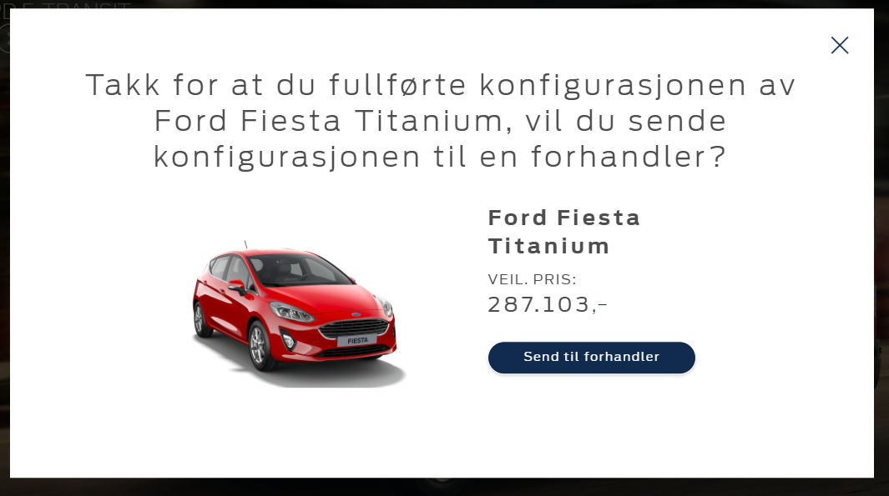

**Browser:**   
All  
  
**Device:**   
All  
  
**Audience rules:**   
All traffic

**QA Links:**

**ALL VISITORS:**

<http://www.ford.no/?at_preview_token=ZqeuUMFiQ2w7fTOY4Rvh8A&at_preview_index=1_1&at_preview_listed_activities_only=true>